

Mini Project Report - 03
Master of Computer Application – GenAI
Semester – I

Sub: Front-End Framework and Technologies
Topic: Student Register Form
By
Name: M.Sanjana
Reg no. : PROV/ASAC/MCA/7/26/077

Faculty Name: Veera Raghav Kathula

Faculty Signature: _______________
Department of Computer Application
Alliance University
Chandapura - Anekal Main Road, Anekal
Bengaluru - 562 106
August 2026

INDEX
SL. NO | NAME OF TOPIC | PG NO
1 | INTRODUCTION | 2
2 | INPUT CODE | 3-5
3 | OUTPUT CODE | 6
4 | CONCLUSION | 7

INTRODUCTION

The Student Registration Form is a web-based form developed using HTML and CSS to collect and display basic student information. The form includes fields for the register number, name, date of birth, gender, email ID, phone number, department, course, section, college name, address, and resume. HTML is used to create the structure and input elements, while CSS is used to style the form with colors, borders, spacing, rounded corners, shadows, and button effects. This project demonstrates the basic concepts of HTML forms and CSS styling.

INPUT CODE
<html>
<head>
<title>STUDENT REGISTER</title>
<style>
h1{
text-align: center;
}
form{
border: 1px solid black;
width: 500px;
margin-left: 300px;
box-shadow: 5px 10px 15px black;
}
label{
margin-left: 110px;
}
#i1{
height: 30px;
width: 200px;
}
form{
background-color: rgb(133, 141, 250);
border-radius: 10px;
}
#b1{
margin-left: 100px;
margin-bottom: 10px;
background-color: rgba(55, 206, 118, 0.534);
width: 50px;
height: 25px;
border-radius: 5px;
}
#b1:hover{
background-color: aliceblue;
}
#i2{
margin-left: 68px;
height: 30px;
width: 200px;
}
#i3{
margin-left: 68px;
height: 30px;
width: 200px;
}
#i4{
margin-left: 50px;
height: 30px;
width: 200px;
}
#i5{
margin-left: 46px;
height: 30px;
width: 200px;
}
#i6{
margin-left: 37px;
height: 30px;
width: 200px;
}
#i7{
margin-left: 68px;
height: 30px;
width: 200px;
}
#i8{
margin-left: 68px;
height: 30px;
width: 200px;
}
#i9{
margin-left: 68px;
height: 30px;
width: 200px;
}
#male{
margin-left: 55px;
}
#Course{
margin-left: 67px;
}
#section{
margin-left: 66px;
}
#i7{
margin-left: 20px;
height: 30px;
width: 200px;
}
#i8{
margin-left: 60px;
height: 30px;
width: 200px;
}
</style>
</head>
<body>
<form>
<h1>Student Register form</h1>
<label >Register number:</label>
<input type="number" id="i1" placeholder="enter you reg id" required><br><br>
<label>Name:</label>
<input type="text" id="i2"><br><br>
<label>DOB:</label>
<input type="date" id="i3"><br><br>
<label>gender:</label>
<input type="radio" id="male" name="gender" value="male">
male
<input type="radio" id="female" name="gender" value="female">
female
<input type="radio" id="others" name="gender" value="others">
Others<br><br>
<label>Email id:</label>
<input type="email" id="i4"><br><br>
<label>Phone no:</label>
<input type="number" id="i5"><br><br>
<label>department:</label>
<input type="text" id="i6"><br><br>
<label>Course</label>
<select name="Course" id="Course">
<option>choose</option>
<option value="MCA">MCA</option>
<option value="MBA">MBA</option>
<option value="M.com">M.com</option>
</select><br><br>
<label>Section</label>
<select name="section" id="section">
<option value="A">section A</option>
<option value="B">section B</option>
<option value="C">section C</option>
</select><br><br>
<label>College name:</label>
<input type="text" id="i7"><br><br>
<label>Address</label>
<input type="text" id="i8"><br><br>
<label>Resume:</label>
<input type="file" id="i9"><br><br>
<button id="b1">Submit</button>
<button id="b2">reset</button>
</form>
</body> </html>

OUTPUT

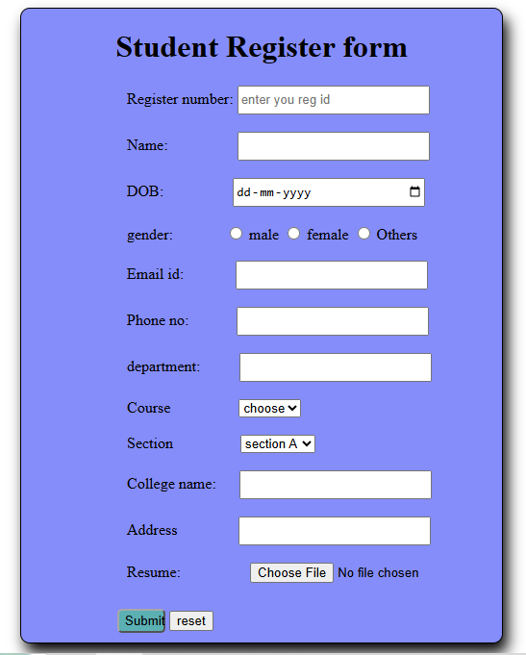

CONCLUSION
The Student Registration Form was successfully created using HTML and CSS. The project demonstrates how different form elements can be used to collect student information in an organized manner. CSS styling makes the form more attractive and user-friendly. Overall, this project provides a basic understanding of creating and designing web forms using HTML and CSS.

